**Database Development and Class Registration**

Travis Henagan

CST499: Capstone for Computer Software Technology

Professor Amr Elchouemi

July 26, 2021

**Database Development and Class Registration**

As I continued the development stage of my MySQL database and class registration pages, I needed to add more to the pages that I had already generated. In the previous week I was able to begin making my database, create a landing page, and create a login page for the users. This week I attempted to expand on these pages with more pages that included a page for students to register for classes, list the classes that they are registered for, and add and delete classes in the schedule. In this paper I will explain the steps I took to continue to add on to the database will more tables, place information in those tables through registration forms and display screenshots of what I was able to come up with.

I began this assignment by creating more tables in my database that I already created. To add tables to the database, I used phpMyAdmin to add tables through SQL statements and other features that are possible with the graphical user interface, that is phpMyAdmin. The tables that I made were named courses, profile, waitlist, along with the table that has the username and passwords of the users saved. To create the tables, I used SQL statements to create the tables in the database. While creating the tables, I was able to specify what types of characters can be used. Below is a screenshot of my tables within the class database on phpMyAdmin

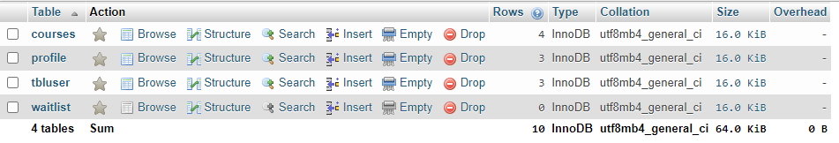

After I created my database tables, I then moved on to creating the pages that the students would use to register for classes. In the previous week I created the pages for the registration and the login which is displayed below.



This week I attempted to create a page for students to register for classes. The page would display a form for students to choose between what courses they would like to take. There would be courses that can only be taken during a specific semester. I attempted to make this page possible but could not get my page to post the results from the database. The code that I created is below

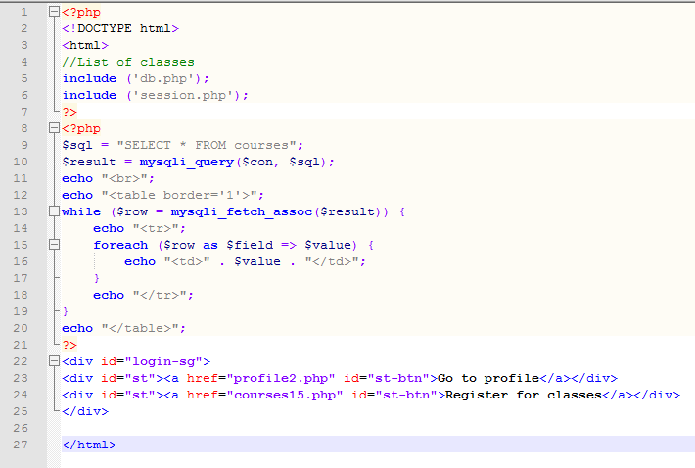

This code is supposed to display the available courses from the list of courses available in the database. The database would be searched by the SQL statement to find the available classes, in the course database table.

Once the page returned the available classes, the student could use the information to choose what classes they could register for. This would then allow the students to add classes to their courses. To add a course to the students’ courses, some PHP code needed to be altered. The SQL statement within the code would only need to be changed. PHP code to do this task is shown below

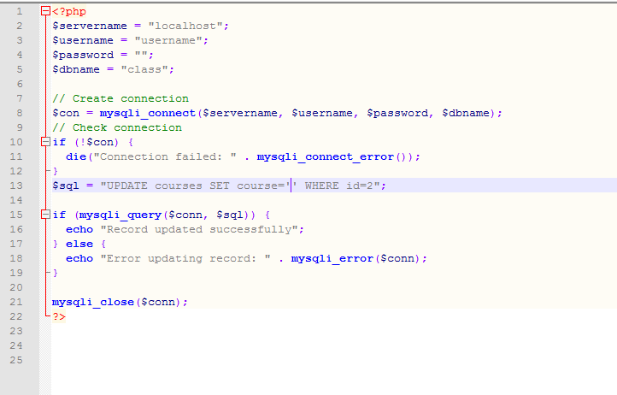

The development of this project became difficult as I needed to create pages that needed more SQL statement and multiple pages to be connected to migrate all information. I was not able to make the page as I wanted, but will need to change somethings before the final project is turned in.